**Ideation Phase**

**Define the Problem Statements**

|  |  |
| --- | --- |
| Date | 8 September 2022 |
| Team ID | PNT2022MID15567 |
| Project Name | Project – Analytics for Hospitals' Health-Care Data |

**Patient Problem Statement Template:**

Create a problem statement to understand your patient's point of view. The Patient Problem Statement template helps you focus on what matters to create experiences people will love.

A well-articulated Patient problem statement allows you and your team to find the ideal solution for the challenges your Patients face. Throughout the process, you’ll also be able to empathize with your Patients, which helps you better understand how they perceive your product or service.

|  |  |
| --- | --- |
| QUESTION | DESCRIPTION |
| Who does the problem affect? | Patients(covid-affected, primary care, emergency care, long term care), hospital management |
| What are the boundaries of the problem? | The boundary contains all activities with the primary purpose of improving, maintaining, and preventing the deterioration of the health status of persons and mitigating the consequences of ill-health through the application of qualified health knowledge |
| What is the issue? | Prolonged stay in hospitals makes the patients feel uncomfortable both mentally and physically and also affect their day-to-day activities . |
| When does the issue occur? | The issue occurs when the patient is in critical condition and in the situation to get admitted. |
| Why is it important that we fix the problem? | Prolonged stay in acute hospitals increases the risk of hospital-acquired infections in older patients and disrupts patient flow and access to care due to bed shortages. |

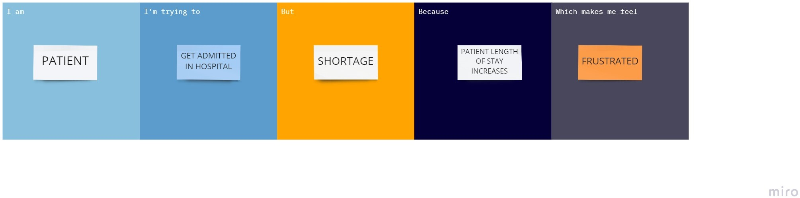

|  |  |  |  |  |  |
| --- | --- | --- | --- | --- | --- |
| **Problem Statement (PS)** | **I am (Customer)** | **I’m trying to** | **But** | **Because** | **Which makes me feel** |
| PS-1 | Patient | Get Admitted in hospital | Shortage | Patient of stay increase | frustrated |